IMPLEMENTING PASSWORD AUTHENTICATION

PASSWORDLESS AUTHENTICATION IS A AUTHENTICATION METHOD TO APPLICATIONS, SYSTEMS OR RESOURCES WITHOUT ENTERING A PASSWORD OR ANSWERING SECURITY QUESTIONS.

PASSWORDLESS AUTHENTICATION IS AZURE AD COMES IN 3 FLAVORS: WINDOWS HELLO FOR BUSINESS, MICROSOFT AUTHENTICATOR, AND FIDO2 SECURITY KEYS.

NOTE: FOR MORE INFORMATION CHECK OUT: [Azure Active Directory passwordless sign-in - Microsoft Entra | Microsoft Docs](https://docs.microsoft.com/en-us/azure/active-directory/authentication/concept-authentication-passwordless)

TO GET TO PASSWORDLESS AUTHENTICATION IN AD: GO TO AZURE AD 🡪 SECURITY 🡪 AUTHENTICATION METHODS. FROM HERE YOU CAN CONFIGURE THE DIFFERENT AUTHENTICATION POLICIES.

BELOW IMAGE I AM SETTING THE USE OF MICROSOFT AUTHENTICATOR APPLICATION. IT IS AS EASY AS IT APPEARS TO BE. I JUST HAD TO ENABLE AND I CHOOSE TO SELECT CERTAIN USERS.

NOTE: THE PURPOSE OF THIS IS TO RECEIVE A CODE VIA APPLICATION AND CONFIRM THAT CODE IN THE SELECTION PROVIDE TO GAIN ACCESS.

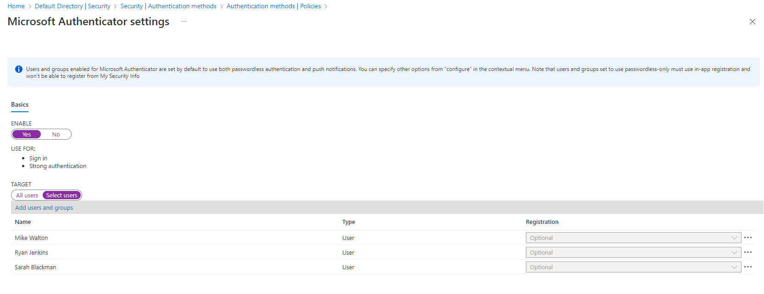

THE OTHER PASSWORDLESS OPTIONS ARE JUST AS EASY IN FOLLOWING THE PROMPTS/WIZARD.